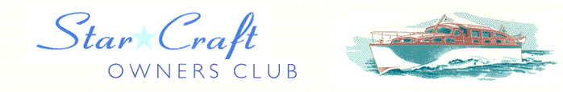

Boat Archives - ‘Hunter’
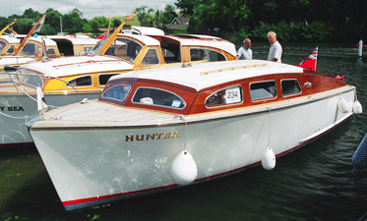

Do you know more about this boat? Tell us!

Length | 25’ | Prior Names | Carefree Two, Lesley Mary, Little Tyke, Hunter
Year Built | 1960 | Build No.
Beam | 7’6 | Hull Construction | Double diagonal amhogany
Draft | 2’6 | Deck Construction | Teak
Engine Make | BMC Navigator | Superstructure Style | Open aft cockpit
Engine Size | 1500cc | Number of Berths | 2
Engine Fuel Type | Petrol | Location | Bourne End

History

1961 | Col K J Pearce purchased CAREFREE TOO for £2,650.00 in April 1961 from  W Bates and Son and registered it in the name of LESLEY MARY  I think this was the ‘Sports Model’ according to the Star Craft ‘Twenty Five’ brochure.
 | CAREFREE TOO replaced another Star Craft which Col K J Pearce owned with the name of LESLEY MARY. This was purchased from W Bates & Son on 22nd September 1954 but was the property of Mr J Law who used the name of ‘Lesley Mary’. I think this was a ‘Cruising Model’ according to the same brochure.
1992 | Col K J Pearce sold LESLEY MARY to Mr R E Furguson of Hurley on 9th April 1992.
 | The above history was provided by Roger A Pearce (July 2007).
1999/2000 | Owned by Richard Furguson of Hurley and sold to Mark Staves of Springfield Marina on the River Lea.
 | Photo of her named LESLEY MARY in Holiday Cruising booklet.
Sep 2001 | Purchased by B Barnett and the name changed to HUNTER. Refurbished by Colin Henwood in the winter of 2001.
2003 | Re-launched and attended Thames Tradional Boat Rally.
2011 | Purchased by Mr Andrew Shaw.

