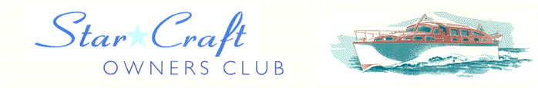

Boat Archives - ‘Hermione’

Do you know more about this boat? Tell us!

Length | 25’ | Prior Names
Year Built |  | Build No.
Beam | 7’6 | Hull Construction
Draft | 2’6 | Deck Construction
Engine Make |  | Superstructure Style
Engine Size |  | Number of Berths
Engine Fuel Type |  | Location | Norfolk Broads / Loddon Marina / Lyddon Marina ?

Owned by Barry Williams.
Larger rear cockpit than other 25’ craft with cabin and wheelhouse approx. 1’ nearer the bow? Source D. Lawrence.

