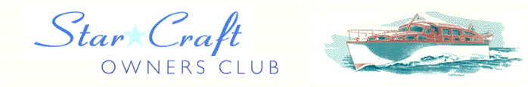

Boat Archives - ‘Herculeen’
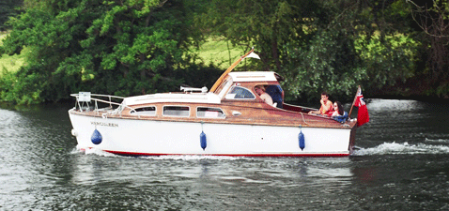

Do you know more about this boat? Tell us!

Length | 25’ | Prior Names | Delorso
Year Built | 1952 | Build No. | 25/29
Beam | 7’6 | Hull Construction | Double diagonal mahogany
Draft | 2’6 | Deck Construction
Engine Make |  | Superstructure Style
Engine Size |  | Number of Berths
Engine Fuel Type | Diesel | Location | Harleyford Marina

History

1952 | Originally named DELORSO and fitted with a Ford V8 side valve engine as used in the V8 Pilot. 3600cc giving 68 HP at 2800 rpm through a Parsons direct drive gearbox. Cost new was £2380.
1965 | Wheelhouse roof added – SOURCE: Stan Timms.
1967 | Owned by a Mr J R Humberstone.
 | Name changed by R A Helmuth and Ilene who owned Hercules Transport. Later owned by Ken Laidler, a leading Volkswagon agent, and then Ben Jones, a fashion photographer, who owned her until about 1978.
1985 | Owned by Kevin Shadbolt of Slough and kept at Crevald's.
1994 | Acquired by Mr & Mrs M Loynes.
1997 | Engine changed to a Ford 1600cc diesel unit - Ford XLD through Borg Warner Direct drive.
1998 | Sold to Bill and Angela Maycock of Ealing. Engine replaced again.
2003 | Sold.

