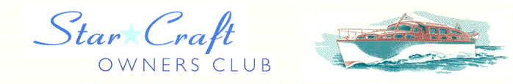

Boat Archives - ‘Hamal’

Do you know more about this boat? Tell us!

Length | 25’ | Prior Names
Year Built | 1956 | Build No.
Beam | 7’6 | Hull Construction | Double diagonal mahogany
Draft | 2’6 | Deck Construction
Engine Make | Chrysler Crown | Superstructure Style | Open aft cockpit
Engine Size | 115 HP | Number of Berths
Engine Fuel Type | Petrol | Location | Hard standing at Seer Green, Buckinghamshire

History
1958 | HAMAL means small bright shining star. (Not to be confused with the 40' Star Craft named HAMEL built 1958 - now WANDERING STAR).
1962 | Mr C F Simmonds.
1964 | Sold to Mr Brian Rutland.
1968 | Sold to Mr Robin Syrett.
1978 - 1988 | Owned during by Denise & Roger Hill. Moored at Bourne End in the Spade Oak Reach at a house named Lingerin. Hull damaged by ice on the waterline, a large amount of re-planking had to be done. Info supplied by Kevin Hill, their son.
 | Attended 9th Thames Trad Boat Rally.
1992 | Purchased by Mr Malcolm Morgan.
1993 | 1993 - Acquired by Terry and Audrey Hollbrook, and currently awaiting restoration retaining the name HAMAL. Now under restoration.

