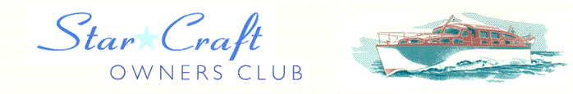

Boat Archives - ‘Franswa II’

Do you know more about this boat? Tell us!

Length | 45’ | Prior Names
Year Built | 1963 | Build No. | 45/1
Beam | 11’6 | Hull Construction | Double diagonal teak
Draft | 3’6 | Deck Construction | Teak
Engine Make | Twin Perkins HT 6.354 (M) | Superstructure Style
Engine Size | 105HP | Number of Berths
Engine Fuel Type | Diesel | Location | Runneymede, on the hard

History
1996 | Owned by Ken Lucas of Parkstone, Dorset.
 | ORIGINALLY BASED ON THE THAMES AT SHIPLAKE AT MR LUCAS HOUSE TAKEN TO DORSET WHEN HE RETIRED SEEN OUT OF WATER LOOKING IN NEED OF TLC REPORT BY CHRIS EDGERLY.
2002 | Purchased by Carol and Martin Reed of Runnymede, who also own ARCADIA.

