Boat Archives - ‘Flying Horse’
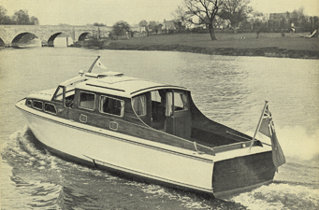

Do you know more about this boat? Tell us!

Length | 40’ but see photo?? | Prior Names
Year Built | 1958 | Build No. | 40/7 ??
Beam | 11’4 | Hull Construction | Double diagonal mahogany. Bottom is copper sheathed to 9” above waterline
Draft | 3’10 | Deck Construction
Engine Make | Twin BMC Commodores BMC57 | Superstructure Style | Open aft cockpit
Engine Size |  | Number of Berths
Engine Fuel Type | Diesel | Location | Malta

History

 | Originally sold to Malta Hotels Ltd., and despatched to "The Phoenicia Hotel", Valletta, Malta.
1959 | Lloyds registered to the Malta Hotels Ltd. REG No 2533-187761
1997 | Seen in Malta.
2000 | Cabin sadly cut off being replaced in different design.

