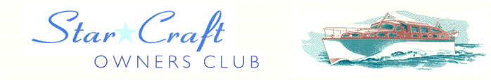

Boat Archives - ‘Festivity’
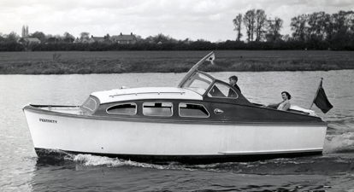

Do you know more about this boat? Tell us!

Length | 25’1951 | Prior Names
Year Built | 7’6 | Build No. | 25/25
Beam | 2’6 | Hull Construction | Double diagonal mahogany
Draft | Ford XLD fitted 1998 | Deck Construction | Cascovered hull & decks
Engine Make | 1600cc | Superstructure Style | Open aft cockpit
Engine Size | Diesel | Number of Berths
Engine Fuel Type |  | Location | Chertsey

History
1951 | Original engine - Morris 51 12 HP petrol.
May 1951 | Featured in Motor Boat & Yachting.
1959 | Registered to Mrs B Birch of London, Lloyds reg. no. 2428.
1995 | Moored at Chambers Boatyard, Bell Weir.
 | Owned by Bruce Pendlebury until Oct 96.
October 1996 | Sold to Mrs Gillian Watson of Ealing.
1999 | Superstructure completely rebuilt during the spring and summer by Peter Towerzey.

