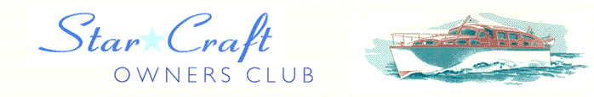

Boat Archives - ‘Etoile de Paris’
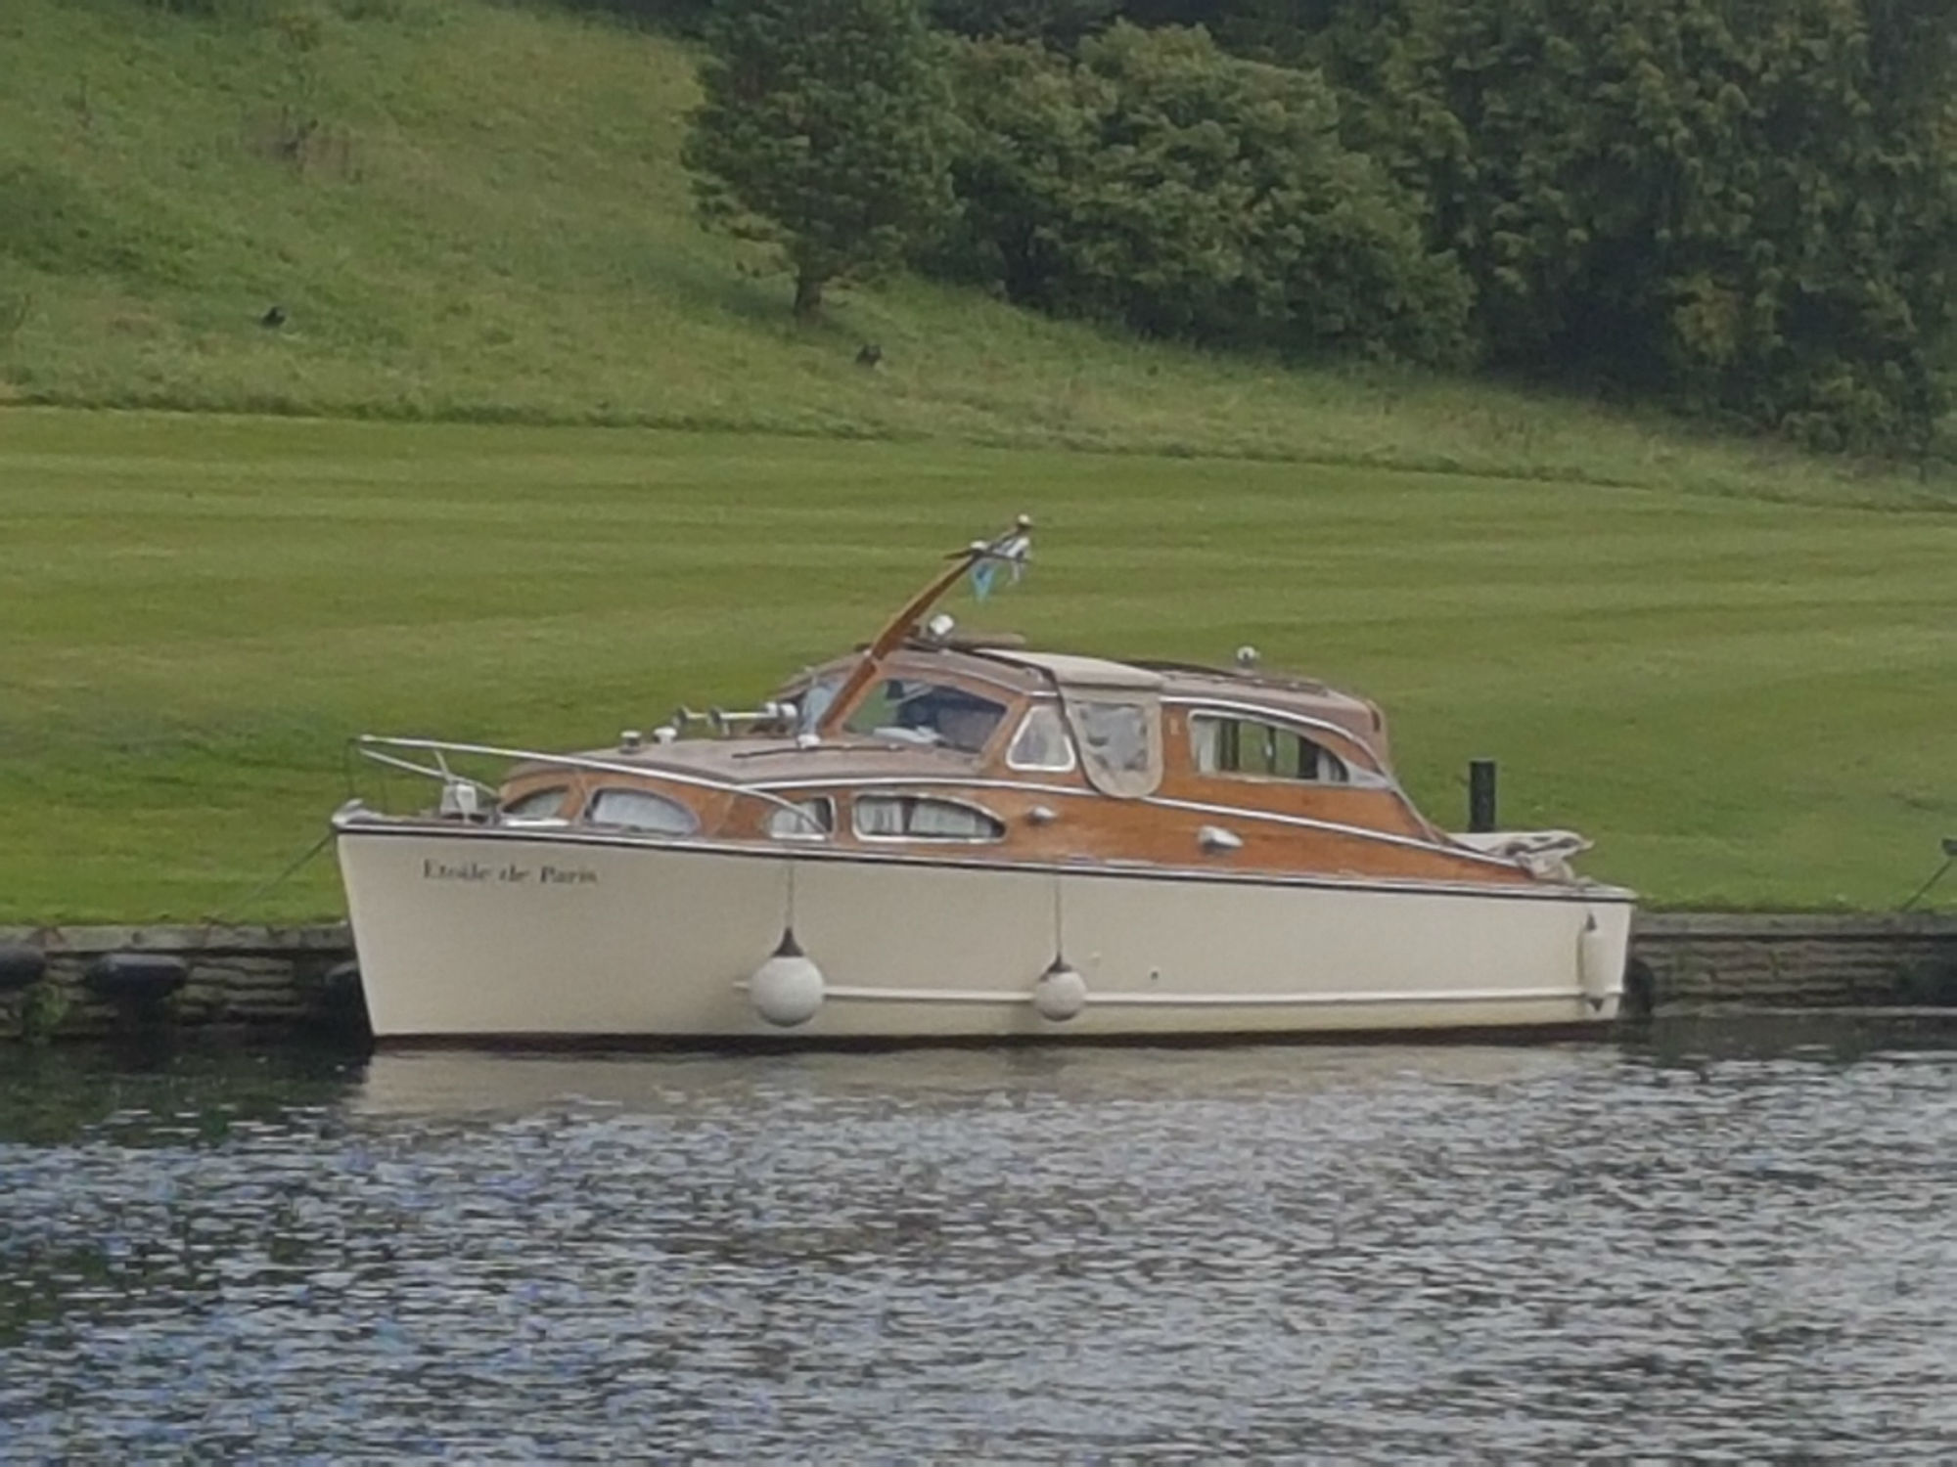

Do you know more about this boat? Tell us!

Length | 30’ | Prior Names
Year Built | 1953 | Build No. | 29/10
Beam | 10’2 | Hull Construction | Double diagonal mahogany, some carvel planking
Draft | 2’9 | Deck Construction | Mahogany
Engine Make | Chrysler Crown 6 cyl, rebuilt 2001 | Superstructure Style | Open aft cockpit
Engine Size | 109 HP (1994) | Number of Berths | 5
Engine Fuel Type | Petrol | Location | Harleyford Marina

History
1953 | Built for Mr A E Adams of Adams Bristow Transport of New Malden, Surrey who was a member of the T.M.C.C. The boat took part in Queen Elizabeth's Coronation river pageant.
 | Name means "Star of Paris"
1959 | Registered to Mr A E Adams, London. Lloyds reg. no. 2281-187364.
1985 | Owned by C D Lilley of Crawley & kept at Shepperton Marina.
September 1992 | Bought by her present owners, Audrey and Terry Holbrook. They spent 10 months on the restoration. Returned to the water for 1993, 40 years after taking part in the 1953 pageant.
1993 | Winner of the Freebody Trophy at the Thames Traditional Boat Rally (TTBR) in Henley.
1995 | Winner of the Bates Wheel (TTBR).
1999 | Winner of the Thames Heritage Trust Cup (TTBR).
 | Below is the proposed text for a Star Craft coffee table book, much discussed but never published! Source: Sue Craft.
“At the end of August, 1992 Terry and Audrey Holbrook found an advert in the Thames Valley Trader for a wooden boat. They didn’t know what a Bates Star Craft was, but when they saw Etoile de Paris they immediately fell in love and bought her. For the next ten months Terry worked tirelessly to restore her to her former glory and in 1993 she was re-launched 40 years after taking part in the 1953 river pageant to celebrate the Coronation. Terry and Audrey have adorned the deck saloon with glasses, mugs and plates that were made to celebrate the Queen’s accession to the throne. The connection with Royalty continued as Etoile de Paris participated in the annual event of Swan Upping from Sunbury on Thames to Abingdon and in 2009 Terry and Audrey were not only presented to The Queen, but they also attended a garden party at Buckingham Palace. Etoile de Paris was also present at Richmond Lock and Weir in 1994 when it was opened by The Duke of York.
Etoile de Paris still retains her original engine though it is no longer used at anything like full power; the boat once had a top speed of about 18 knots, but today she is mainly used on the upper Thames and the speed limit is 5 knots. Etoile de Paris regularly attends the Henley Festival and Thames Traditional Boat Rally, except in 2002 when Terry famously applied two days too late and was rejected! In 2001 Etoile de Paris joined four other Star Craft on a successful trip to St. Katharine Docks.
Terry and Audrey also own a Star Craft 25’ called ‘Hamal’ which is work in progress.”
Sadly, Terry died in April 2002 and Audrey took the boat to Benson and continued to skipper her until her death in 2014.
2017 | Purchased by Ben Ludford. Message received in January, 2018: “She's currently out of the water having some hull work done, paint and anti foul etc. Transom also to be revarnished. We have her currently moored at Harleyford Estate.  I was quite busy last year with work and refitting the galley and hot water system, so missed the events. We should be more involved this year all being well. Thanks, Ben”

