Boat Archives - ‘Elveseter’
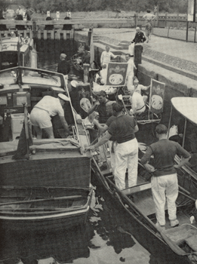

Do you know more about this boat? Tell us!

Length | 25’ | Prior Names | Cylora Three, Elpico
Year Built | 1949/1950 | Build No. | 25/20
Beam | 7’6 | Hull Construction | Double diagonal mahogany
Draft | 2’6 | Deck Construction
Engine Make | Morris Vedette | Superstructure Style | Open aft cockpit
Engine Size | 1500cc | Number of Berths
Engine Fuel Type | Petrol | Location

History
1949 | Built for Cyril Scott of Smiths Crisps. (He also owned a Slipper stern, called CYLORA II and later a 40' Bates for which he kept the name CYLORA.
1957 | Sold to Mr G S Lee. Name changed to ELPICO. Lloyds Reg. No. 2145-184593 to Gordon S Lee, London.
1959 | Sold to Mr R E Hill. Name changed to ELVESETER.
1963 | Photo with swan uppers in "COUNTRY LIFE OF THE THAMES".
1996 | Owned by a Mr Mark Onsworth?

