Boat Archives - ‘Donna Tomara’
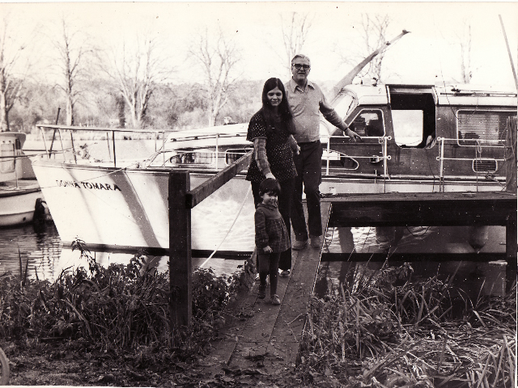
Do you know more about this boat? Tell us!

Length | 40’ | Prior Names | New
Year Built | 1958 | Build No. | 40/9
Beam | 11’ | Hull Construction | Double diagonal mahogany
Draft | 3’10 | Deck Construction | Teak
Engine Make | Twin BMC Commodores | Superstructure Style
Engine Size | 3.4 litre | Number of Berths
Engine Fuel Type | Diesel | Location
History
19th May 1958 | First purchased by a Mr Skyrme.
1963 | Article in MBY.
1975 - 78 | Owned by Mr. Peter Messer. Cruised extensively in Europe and the canals.
1974 | New laid deck.
1997 | Seen afloat on the North East Coast of England - Source: Mr & Mrs Messer.
 | Where is she now?
 | Carries a Stuart Turner Generator.

