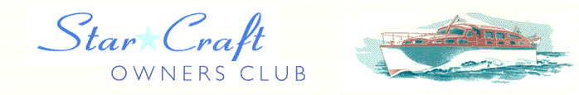

Boat Archives - ‘DODDIE TWO’
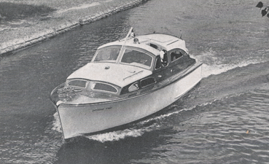

Do you know more about this boat? Tell us!

Length | 30’ | Prior Names | Lady of Avrian, White Eagle
Year Built | 1955 | Build No.
Beam | 10’3 | Hull Construction | Double diagonal mahogany
Draft | 2’9 | Deck Construction
Engine Make | Chrysler Crown RM2 (main) & Morris 55 (wing) | Superstructure Style
Engine Size | 109 HP | Number of Berths
Engine Fuel Type | Petrol | Location

History
1955 | Built for Mr E Lytton-Partington of Gerards Cross and originally named "Doddie Two".
1965 | Sold to D W Twiggs of John Twiggs Motors, Beckenham.
1970’s | Purchased by Philip Howe. Per Mr Howe: We purchased her from Marine Auctions at Christchurch. At the time she was named WHITE EAGLE and we were told that she had come from a Thames hire fleet. She was in a poor state and the main engine seized. However there were a couple of concourse plaques on the bulkhead showing the name DODDIE TWO, so we changed the name back. After rebuilding the engine, replacing planks, cabin tops, upholstery etc., she returned to her former glory and was cruised on the Severn until her sale in 1979. I was told recently that she was laying derelict in a local yard, but on investigation was unable to locate her. Incidentally, when purchasing spares to rebuild the Chrysler Crown, we were told that the engine was much older than the boat and had probably been fitted as a reconditioned unit when the boat was originally built.
1991 | Acquired by Mr Colin Forester-Morgan of Kidderminster. The name was changed from LADY OF AVRIAN back to DODDIE TWO.
1993 | Sold?
 | On hard standing on River Severn (check location with Mark Cooper).

