Boat Archives - ‘DERELYN’
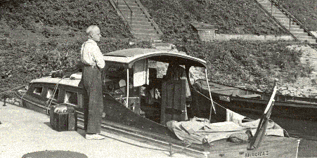

Do you know more about this boat? Tell us!

Length | 25’ | Prior Names | Batriorca II, Purley Way
Year Built | Circa 1946/1947 | Build No.
Beam | 7’6 | Hull Construction | Double diagonal mahogany
Draft | 2’6 | Deck Construction
Engine Make | Twin Vosper 45 V8 engines | Superstructure Style
Engine Size |  | Number of Berths
Engine Fuel Type | Diesel | Location

History
Originally named BATRIORCA II.
One of the very early 25 footers, circa 1948 or before.
1959 Registered to T H Plumridge - LLOYDS REG No 1783 in 1958 Later owned by D.W. Adamson in 1960s - SOURCE: Stan Tims.
Lloyds #1820 (1959).

