Boat Archives - ‘DELPHI’
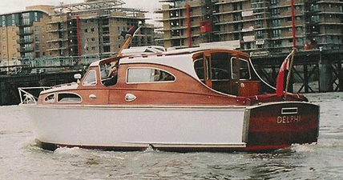

Do you know more about this boat? Tell us!

Length | 30’ | Prior Names | Jumbo, Sylvia
Year Built | 1960 | Build No.
Beam | 10’2 | Hull Construction | Double Diagonal Mahogany
Draft | 2’9 | Deck Construction | Teak
Engine Make | Originally BMC Navigator (petrol), replaced in 2001 with Nanni (diesel) | Superstructure Style | Open aft cockpit
Engine Size | 43 HP | Number of Berths | 4
Engine Fuel Type | Diesel | Location | Shepperton

History
1960 | Named "Jumbo" when new. Later named "Delphi".
1996 | Owned by Barry Graham and renamed "Sylvia" by him, taking the registered name from the 1916 built skiff Sylvia built by Messums.
2000 | New owner, Richard Binch. Restored by M Dennett. Name changed back to "Delphi". Moored near Teddington lock.
2005 | Purchased by Adrian Harvery. Moved to Shepperton.
2010 | Moved to Chertsey Reach.

