Boat Archives - ‘Cleo’
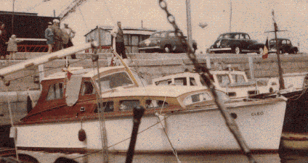

Do you know more about this boat? Tell us!

Length | 25’ | Prior Names
Year Built | 1955 | Build No. | 25/31
Beam | 7’6 | Hull Construction | Double diagonal mahogany
Draft | 2’6 | Deck Construction
Engine Make | Parsons Ford V8 direct drive to a 13 x 11 inch prop. | Superstructure Style | Aft cockpit
Engine Size | 80 HP | Number of Berths
Engine Fuel Type | Petrol | Location | Woottens Boat yard

History
 | On build sheets as CLEO. Built for one T.A. Morgan. Built with an open cockpit at the same time as MAGIC ROSE.
 | Later owned by R.J. Salter of London.
1958 | Mrs Edna Bird of London. (from Lloyds Register) LLOYDS REG No 1430 184682

