Boat Archives - ‘Crystella’
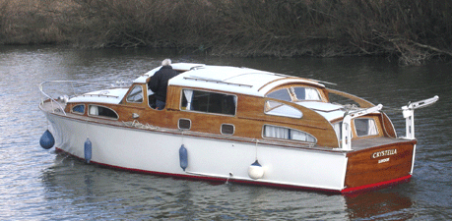

Do you know more about this boat? Tell us!

Length | 33’ | Prior Names
Year Built | 1963 | Build No. | 33/25
Beam | 10’3 | Hull Construction | Double diagonal teak
Draft | 2’9 | Deck Construction | Teak
Engine Make | Twin BMC 1.5 | Superstructure Style | Closed aft cockpit
Engine Size | 1500cc | Number of Berths
Engine Fuel Type | Diesel | Location | Weybridge

History
1963 | Built for a Mr Peter Jenkins of Huntingdon, and thought to be the vessel displayed by Bates at the 1963 boat show. Directly after fitting out, she was cruised to the Great Ouse, Cambs, and was kept on the east coast until March 1996.
1996 | March, returned to home waters.
1979 | Purchased by David Stuart.
1990 | For sale at L H Jones & Son Ltd.
September 1991 | Purchased by Roger and Heather Greene.
1996 | Winner of the Bill Gardam Trophy and the House & Garden Chalice at the Thames Traditional Boat Rally.
1997 | Winner of The Bates Wheel, Thames Traditional Boat Rally. Moved to Weymouth harbour.
1999 | Moved by road to the Severn Motor Yacht Club, River Severn, Worcester.
2003 | Purchased by John Williams of Chertsey.
February 2004 | Hull repainted by Terry Dann at Penton Hook Marina.

