Boat Archives - ‘Centurette’
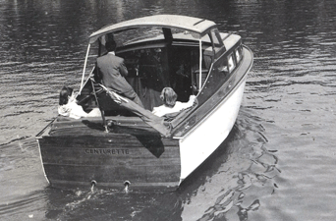

Do you know more about this boat? Tell us!

Length | 25’ | Prior Names
Year Built |  | Build No.
Beam | 7’6 | Hull Construction
Draft | 2’6 | Deck Construction
Engine Make |  | Superstructure Style
Engine Size |  | Number of Berths
Engine Fuel Type |  | Location

History
An early boat, has square windows.
An owner - Mr Turner?
Believed to have gone to the Medway. SOURCE: Stan Tims

