Boat Archives - ‘Ceak’
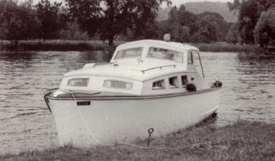

Do you know more about this boat? Tell us!

Length | 25’ | Prior Names
Year Built | 1947 | Build No.
Beam | 7’6 | Hull Construction | Double diagonal mahogany, later re-planked carvel from waterline down
Draft | 2’6 | Deck Construction
Engine Make | Morris Vedette Side Valve | Superstructure Style
Engine Size |  | Number of Berths
Engine Fuel Type |  | Location

History
1947 | An early Star Craft with square windows
1964 | Purchased at Benson Cruise Station for £750
1966 | Chrysler Crown 115 HP changed to Morris Vedette Side Valve.
 | From Mr. K. Pearce by John Weeks could get under Osney Bridge with 2" clearance!
1969 | 18th October - Sold at Bushnell's Auction for £325, less commission.

