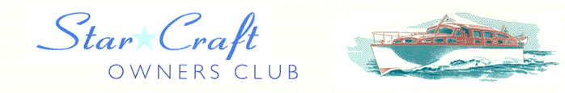

Boat Archives - ‘Carician’
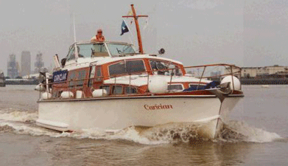

Do you know more about this boat? Tell us!

Length | 40’ | Prior Names
Year Built | 1970 | Build No. | 40/23
Beam | 11’6 | Hull Construction | Double diagonal teak
Draft | 3’10 | Deck Construction
Engine Make | Twin Volvo TMD41 | Superstructure Style | Flybridge
Engine Size | 200HP | Number of Berths
Engine Fuel Type | Diesel | Location | France

History
1970 | One of the last of the Star Craft to be built, she was owned by a Mr McDonald in 1970.
1976 | Owned by John Bates.
1988 | Owned by David Antill.
 | Moved from the Thames to France where she is expected to tour the French canals over the next few years.
Winter 1993/1994 | Extensive refurbishment and re-wire. Her original twin 175 HP Perkins' diesels were replaced with Volvo TMD41 engines. Interior rebuilt by Michael Dennett of Laleham.
 | Original engines (twin Perkins HT 6.354 diesels 175 HP) now installed in ASTERISK*.
1996 | Taken to Guernsey, the Channel Islands.
 | Now owned by Michael Mortimer.
Sep 2003 | Moved from the Thames to France where she is expected to tour the French canals over the next few years.

