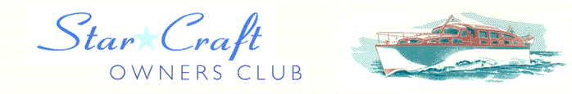

Boat Archives - ‘Belle Epoque’
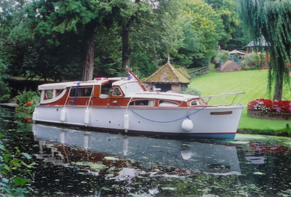

Do you know more about this boat? Tell us!

Length | 33’ | Prior Names | Deirdre Louise
Year Built | 1961 | Build No.
Beam | 9’6 | Hull Construction | Double diagonal teak
Draft | 2’9 | Deck Construction | Varnished teak
Engine Make | Twin Ford Watermota | Superstructure Style | Open aft cockpit
Engine Size | 1600cc | Number of Berths | 4 + 2
Engine Fuel Type | Petrol | Location | Preston Crowmarsh
History

1961 | This is the only remaining 33' Star Craft with an open rear cockpit. (The other was dropped while being lifted by crane)!
 | Built for W A Howell, (the 3rd boat built for him by Bates) & named after his daughter. He owned 25' DEIDRE LOUISE (note different spelling) changed at some time on the 33' boat (photo on file from Classic Boat). Lloyds registered.
1969 - 72 | Owned by W. Bates & Sons, and used by Mrs Beryl Bates (wife of Leonard).
1972 | Purchased by Michael Martin from Bates of Chertsey, re-engined.
1975 | Purchased by Mike & Sylvia Morrell. Mike was a founder of the Star Craft Owners Club.
1979 | Previous BMC Vedettes replaced by Watermota Sea Tigers.
June 1991 | Registered with the TVBC.
1994 | Owned by Roy Griffiths of Sunbury.
1996 | Sold to Mr Brian Hawkins of Farnham.
2004 | Sold to Tony and Gloria Mayes of Wargrave, previous owners of CAREFREE, a 20' Star Craft.
2005 | Name changed from DEIRDRE LOUISE to BELLE EPOQUE.
 | Current owners are David and Sheila Newling-Ward.
2017 | Current owner is now Ms Jo Ledbrooke.

