Baqooba II
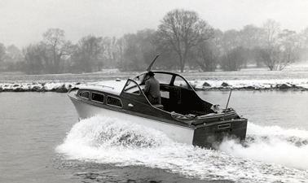

Do you know more about this boat? Tell us!

Length | 25’ | Prior Names | Octavia, La Kajali
Year Built | 1956 | Build No. | 25/24
Beam | 7’6 | Hull Construction | Double diagonal mahogany
Draft | 2’6 | Deck Construction
Engine Make | Twin Meadows Kitiwake  4 cyl. Morris | Superstructure Style | Open aft cockpit
Engine Size | 115 HP | Number of Berths
Engine Fuel Type | Petrol | Location | Wales

History
1956 | This is the only 25ft Star Craft known to have twin engines, listed on build sheets.
 | All the windows are squarish with smaller than normal radii corners. This is an early boat.
 | MBY ARTICLE ORIGINALLY FITTED TWIN CHRYSLER CROWNS. Some confusion over history. Story in MBY relating to 1956 Boat show. SOURCE: Motor Boat & Yachting - April 1956.
 | Named OCTAVIA. Powered by twin Meadows Kitiwake 4cyl petrol engines, she was built for Mr Palmer.
 | Purchased by a Mr Henshall who retained the name when he changed to a larger 33' Star Craft that he had built by Bates.
 | Later became LA KAJALI when owned by George Newland who also kept this name when he changed boats.
1996 | Purchased by Colin Wilshaw who also owns ELLA DAPHNE TWO and SLAINTE VARE, both 25ft. Name changed back to original, "BAQOOBA II". Being restored, stored under cover in large dry workshop in Wales.

