Boat Archives - ‘Asterisk *’
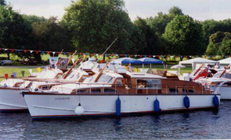

Do you know more about this boat? Tell us!

Length | 45’ | Prior Names | White Minx
Year Built | 1962/63 | Build No. | 45/2
Beam | 11’ 6” | Hull Construction | Double diagonal teak
Draft | 3’ 6” | Deck Construction | Teak
Engine Make | 2 x Perkins HT6.354 | Superstructure Style | Flybridge
Engine Size | 2 x 175 HP | Number of Berths
Engine Fuel Type | Diesel | Location | Wargrave

History
1979 | Robin Pallot of St Helier Jersey.
Until 1984 | Dieter and Margaret Bauer, Kensington, London.
1984 | Purchased by Tony Goff of High Wycombe. Kept at Thames and Kennet Marina 1984-1989.
1989 | Purchased by Kenneth and Mavis Mappin of Sheffield, Yorks.
1991 | Martin Brown of Scunthorpe, South Humberside.
1998 | Purchased from D B Threadgould of Sheffield.
1994 | Owned by Martin & Anita Brown of Scunthorpe.  Original 2.5 BMC diesels (EX4 Taxi type) were replaced by HT6.354 Perkins removed from CARICIAN.
1997 | Sunk.  Rebuilt by Stanilands of Hull. Moored on the River Trent.
July 1998 | Entered in the Phillips auction at Henley, (Lot No 176) - Not sold.
Oct 1998 | Subsequently sold to Peter Stimpson. Name changed to "Asterisk *"  Lloyds Reg. No. on 340061 rt 15 51/100.

