Boat Archives - ‘Argus Star’
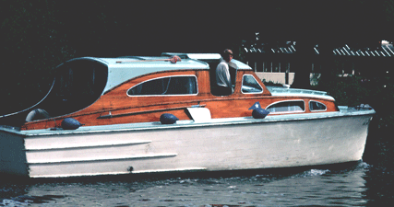

Do you know more about this boat? Tell us!

Length | 25’ ? | Prior Names
Year Built |  | Build No.
Beam |  | Hull Construction
Draft |  | Deck Construction
Engine Make |  | Superstructure Style
Engine Size |  | Number of Berths
Engine Fuel Type |  | Location

History

