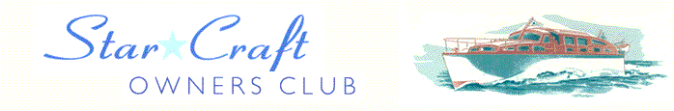

Boat Archives - ‘Arcadia’
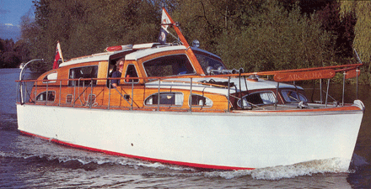

Do you know more about this boat? Tell us!

Length | 33’ | Prior Names
Year Built | 1964 | Build No. | 33/33
Beam | 10’ 2” | Hull Construction | Double diagonal mahogany
Draft | 2’ 9” | Deck Construction | Teak
Engine Make | Twin BMC Captain | Superstructure Style | Closed aft cockpit
Engine Size | 1500cc | Number of Berths
Engine Fuel Type | Diesel | Location | Runnymede

History
1968-73 | F S Slinger of Egham, Surrey.
1973-85 | T S Hoeffer, London & Norfolk.
Sept. 1985 | Purchased by Mr Keith Beautement. Extensive restoration under taken. Probably the most intensively used Bates on the Thames, and regarded with some suspicion by every swan on the river having taken part in most of the Swan Upping runs.
1996 | Acquired by Martin & Carol Reed of Egham, who also own FRANSWA II, a 45' Star Craft.

