Boat Archives - ‘Amoreena’
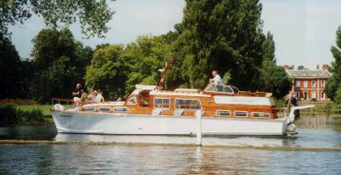

Do you know more about this boat? Tell us!

Perkins | 45’ | Prior Names | Sauseagal II
Year Built | 1969 | Build No. | 45/6
Beam | 11’ 9” | Hull Construction | Double diagonal teak
Draft | 3’ 9” | Deck Construction
Engine Make | Twin Perkins HT 6.354 | Superstructure Style | Flybridge
Engine Size |  | Number of Berths
Engine Fuel Type | Diesel | Location | Goring

History
 | Was named 'SAUSEAGAL II’ from build sheets.
1979/84 | Owned by Don Payen.
1996 | Sold.
1998 | Seen upriver in very good condition.
1999 | Attended Trad Boat Rally.
2006 | Update from owner Bob Halley provided in March 2006:  “I bought 'Amoreena' in the early nineties via Johnny Bates. I fell in love with the Bates Starcraft and knew that there were only a few of the 45's around. He found her on the south coast and she was at that time named 'Sauceagal II'. I bought her back to the Thames where I decided to do repairs and improvements. I had no idea at that time the condition she was in. 2½ years later, a virtual total rebuild of both engines and structure, I had 'Amoreena'  Needless to say I love 'Amoreena' and try to keep her in the best condition I can. She is at the moment in her winter storage at Paul Bushnell's and Guy Wooton is doing some work on her before she returns to Goring at the end of April. Unfortunately I don't get to use her as much as I would like, in fact last season at total of 5 trips and not too far from home. I am hoping that this season I will be able to enjoy her a little more.”
Feb 2017 | Contact received from the new owner, Lynn Atkin:  “I am the new custodian of Amoreena. I live in Guernsey.  She is with Tim Clarke at Portland having the shoddy work rectified that was done to her in Chichester. She is still looking good and joining my fleet of classic boats.  On the trip from Hamble to Portland, she still managed 17.5 knots. The journey was nice and smooth but wet, typical Star Craft as my partner says.  Glad to see that some one has picked the website up again and would love to join the club. All the best, Lynn”

