Boat Archives - ‘Ahmednagar Queen’
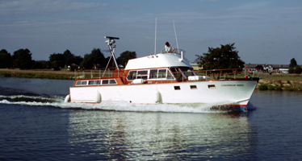

Do you know more about this boat? Tell us!

Length | 47’ | Prior Names
Year Built | 1975/76 | Build No. | 47/1
Beam |  | Hull Construction | Double Diagonal Teak
Draft |  | Deck Construction | Teak
Engine Make | 2 x Perkins | Superstructure Style | Flybridge
Engine Size | 2 x 175HP | Number of Berths
Engine Fuel | Diesel | Location

History
1979 | This is the only Star Craft to be designed by John Bates and Terry Dann. Per Terry Dann, the boat measured 46' and the decks were one foot higher than normal. Deck prisms were installed to encourage light in the forward cabin area.  She was built for Pete Townshend of "The Who" and had moorings at Goring, Twickenham and on the Cornish coast. Per Terry Dann (Bates boat builder), the name Ahmednagar is from an Indian region that Pete Townshend visited.  The boat was shipped to Seattle, USA as deck cargo. Before shipping the whole of the superstructure was painted white. Where is she now?

